1. Line Chart – Daily Page Views
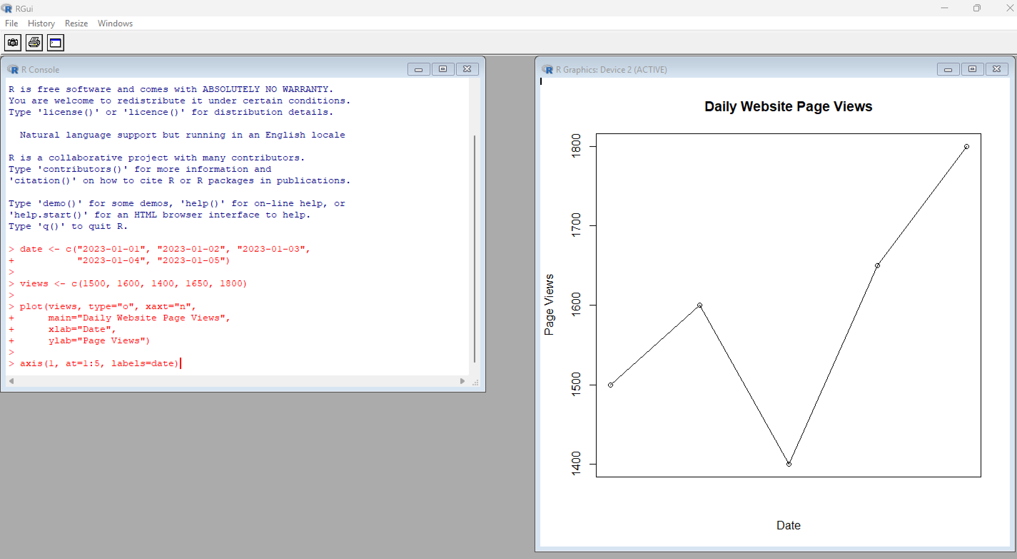
2. Bar Chart – Click-through Rate
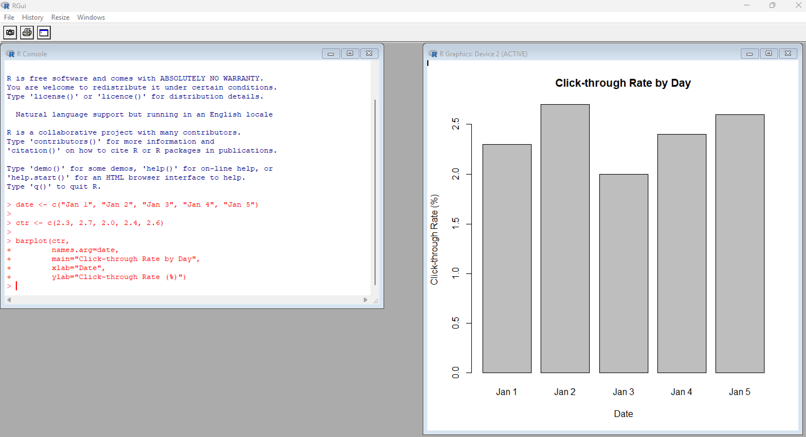

3. Stacked Area Chart – User Interactions
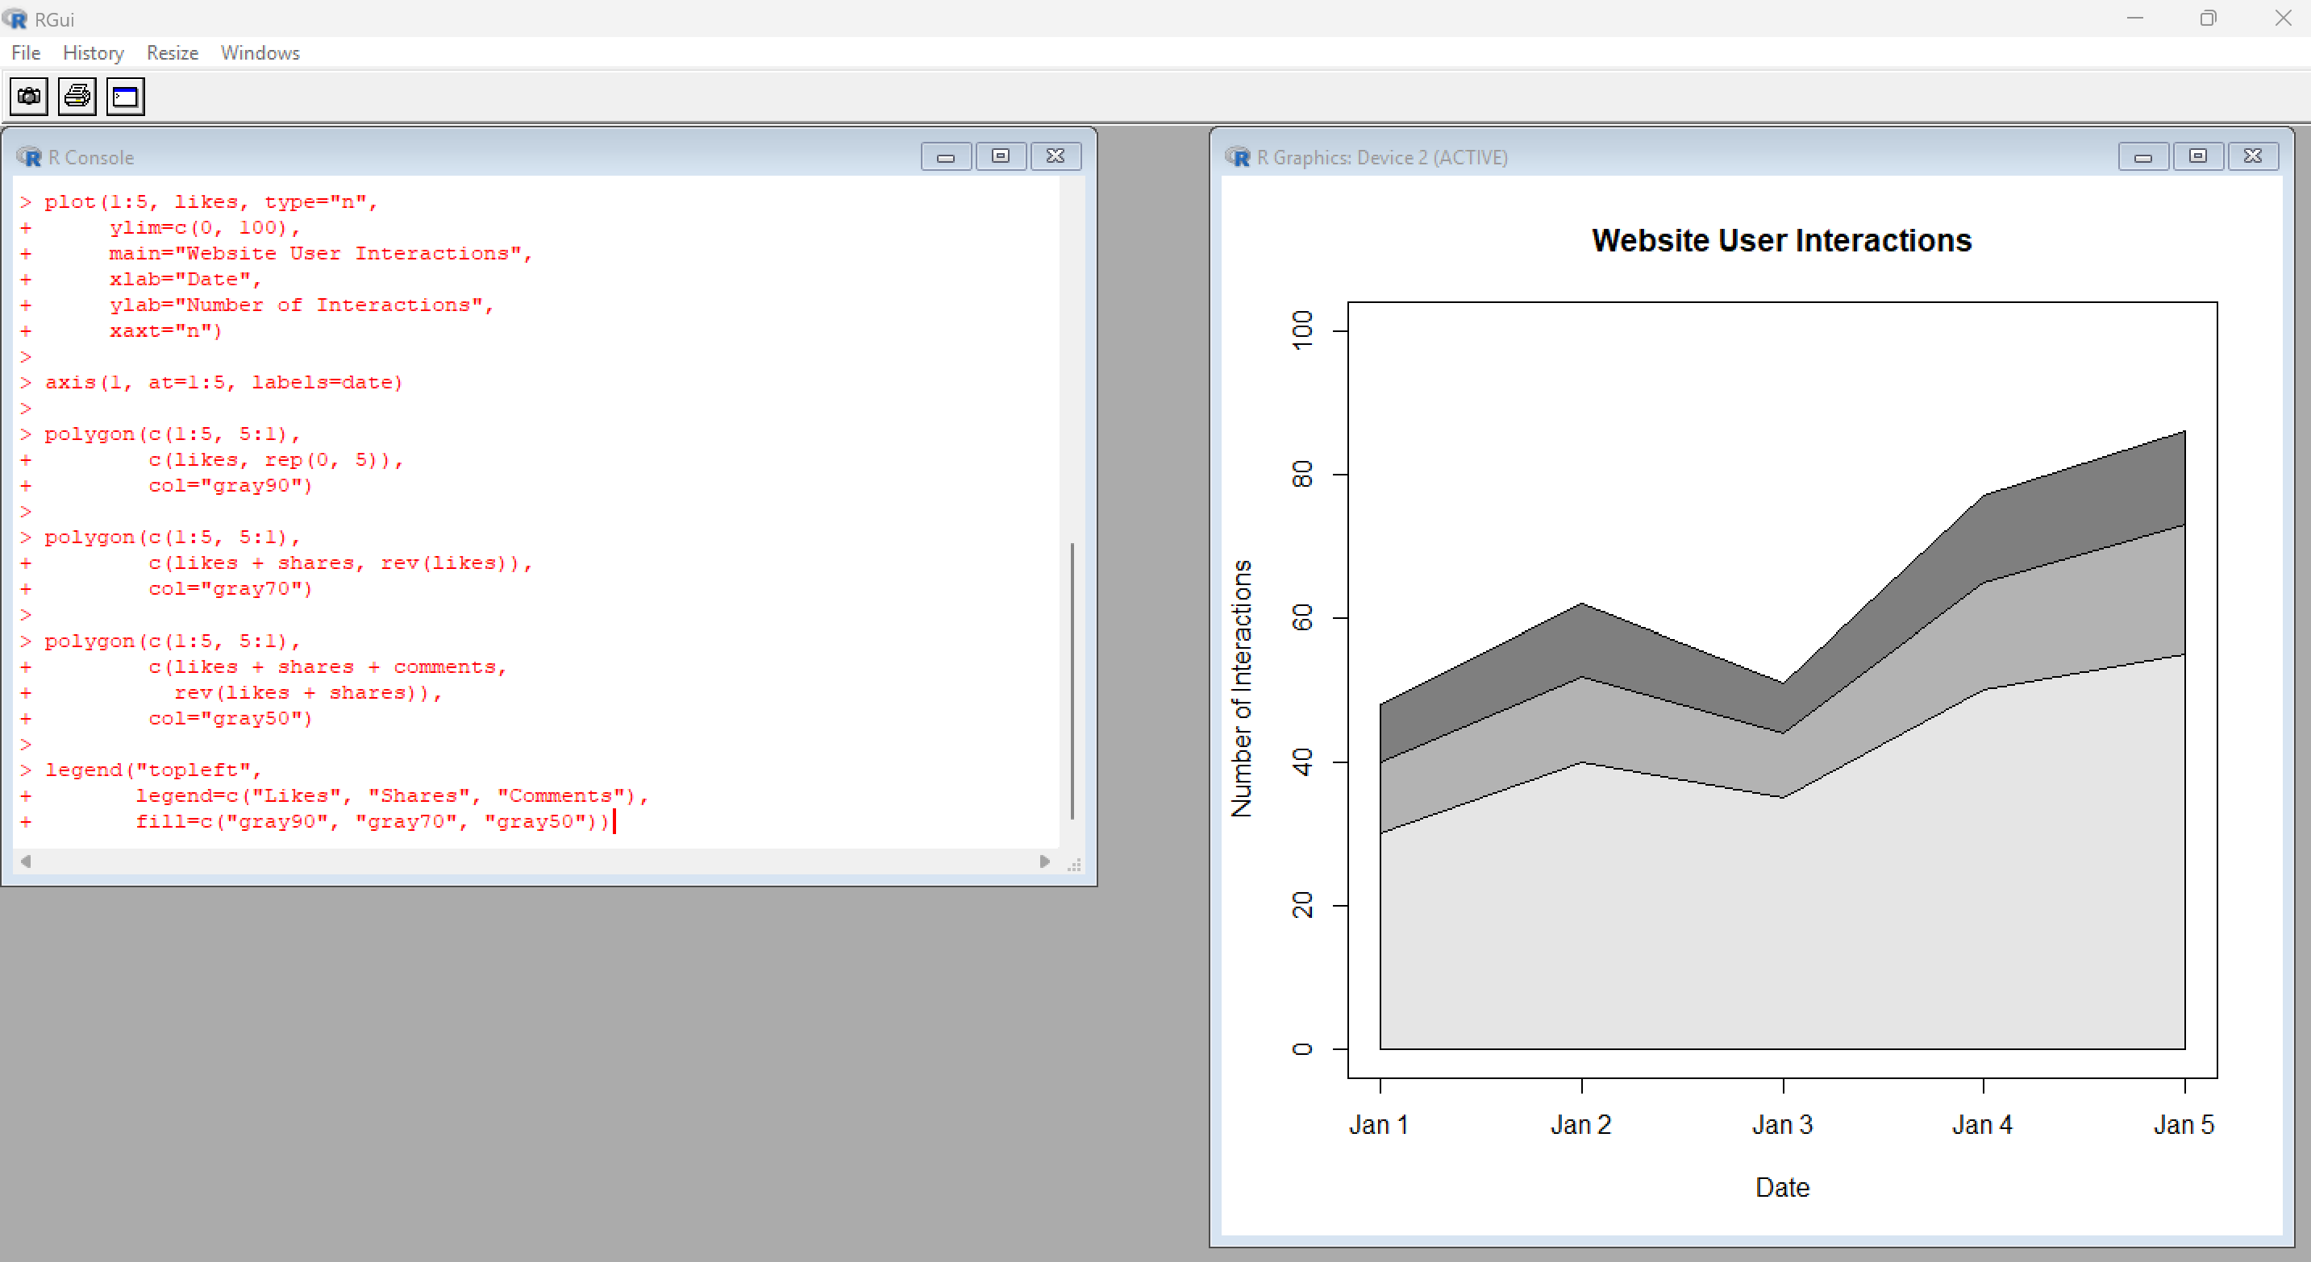

4. Tableau Dashboard
